BELLE REALTY OF LAFAYETTE, LLC

PO BOX 62230, Lafayette, Louisiana 70569, Cell Phone: 337-288-5411, Email: adam@belle-realty.com

February 19, 2020

VIA ELECTRONIC MAIL
Nic Mclaughlin
james.mclaughlin@jasonsdeli.com

Re: Proposed Renewal Terms - Belle Realty and Jason’s Deli -149 Arnould Blvd., Lafayette, Louisiana

Nic, it was a pleasure speaking with you again today and I am looking forward to working with you on the renewal of the Lease Agreement for the Jason’s Deli located at On The Blvd. Shopping Center. I have confirmed the following renewal terms for this space which are:

Renewal Options | Base | Cam | T/I | Total | Monthly
10 year w/ 5 year option
Years 1-5 | $15.50 | $2.10 | $1.85 | $19.45 | $7,476.90
Years 6-10 | $16.50 | $2.10 | $1.85 | $20.45 | $7,861.32
Option Years 1-5 | $17.50 | $2.10 | $1.85 | $21.45 | $8,245.74
5 year w/ 5 year option
Years 1-5 | $16.75 | $2.10 | $1.85 | $20.70 | $7,957.43
Option Years 1-5 | $17.75 | $2.10 | $1.85 | $21.70 | $8,341.84

Based on our conversations it appears we are in agreement that the ten (10) year renewal term with a five (5) year option to renew is fair and the best option for both Jason’s Deli and Belle Realty. Accordingly, included with this letter is a Fourth Addendum to Lease Agreement simply extending the term of the lease for an additional ten (10) years and granting a five (5) year option to renew all at the rates set forth above.

As you are aware, the shopping center is undergoing several upgrades and improvements. Most of which have been completed and the remainder are scheduled to be completed within the next 30-45 days. These include a new energy conservative roof, an updated color scheme, the complete upgrading of lighting including all new exterior lighting fixtures with high-end remotely connected color adjustable bulbs, new parking lot lighting, and a newly painted parking lot. Other improvements are wireless Internet for customers and bike racks. This year, Belle Realty will initiate an updated marketing plan to help introduce new customers to the Shopping Center. It will focus on the products and services that tenants offer and the shopping experience customers can enjoy at this center which are unique and set it apart from other shopping destinations.

One thing that we briefly touched on during our last conversation is that Belle Realty is working on planning an event which will highlight the renovations which have taken place at the shopping center as well as focus on new tenants and existing tenants who have recently renewed leases. In the next few weeks, we will be identifying the businesses within our center who fit their required criteria and Belle Realty would certainly like to include Jason’s Deli as it would be mutually beneficial for both of us that Jason’s’ Deli be included in the spotlight. Accordingly, as we discussed, as long as we have received the fully executed Fourth Addendum to Lease Agreement on or before March 10, 2020, I will be able ensure that it is.

In addition to the above, please find the following information pertaining to On The Blvd. Shopping Center.

Exhibit A - Fourth Addendum to Lease Agreement.
Exhibit B - Tenant List as of February 19, 2020.
Exhibit C - Site Map as of February 19, 2020.
Exhibit D - Demographic Information for the area surrounding On The Blvd Shopping Center.
Exhibit E - Pictures of the exterior of Jason’s Deli located at On The Blvd Shopping Center.

Please let me know if you have any additional questions or concerns. Thank you.

Exhibit A
Fourth Addendum to Lease Agreement

[please see attached PDF]

Exhibit B
On The Blvd Shopping Center
Tenant List

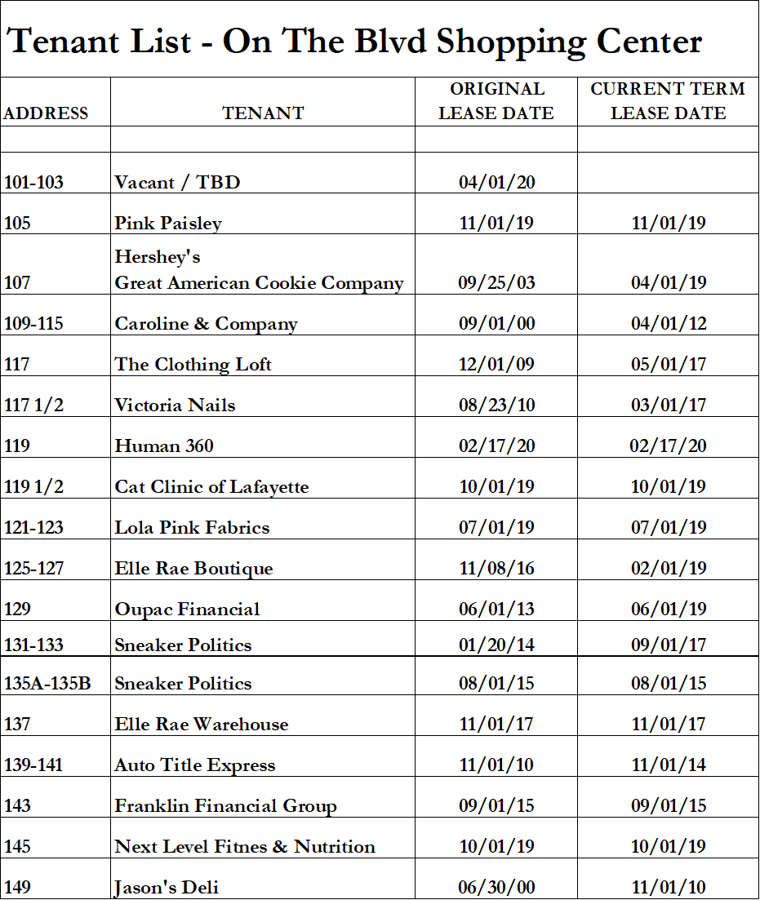

Exhibit C
On The Blvd Shopping Center Site Map

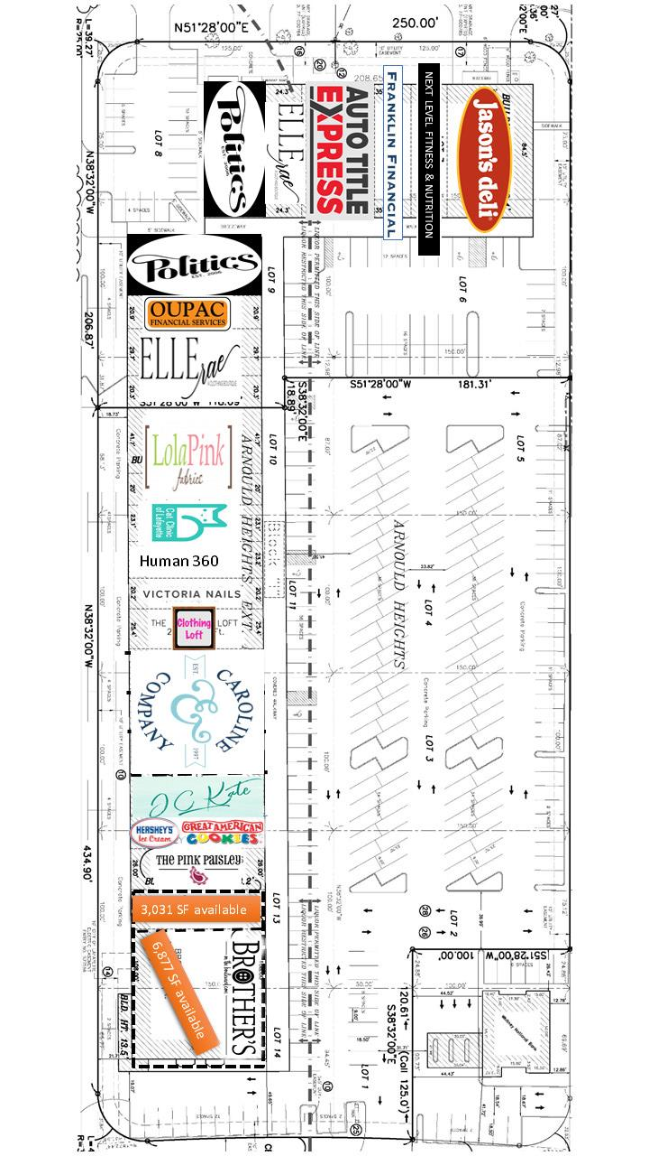

Exhibit D
On The Blvd Shopping Center
Demographic Information

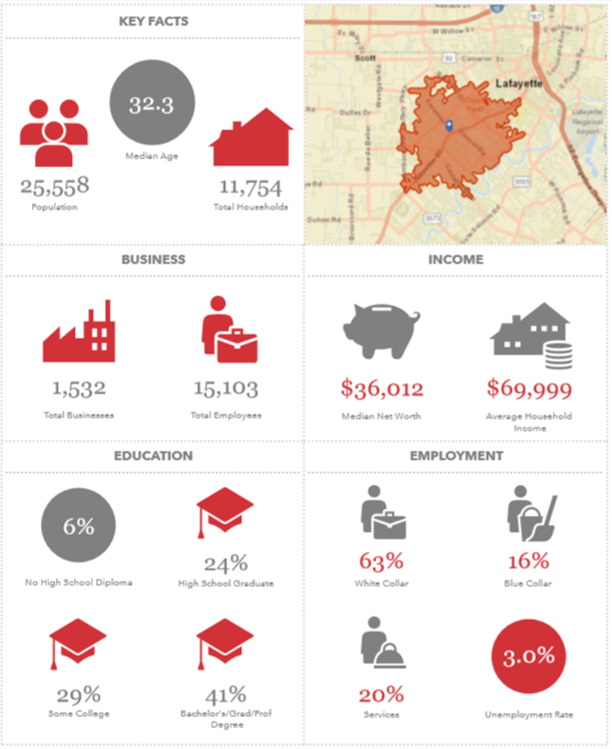

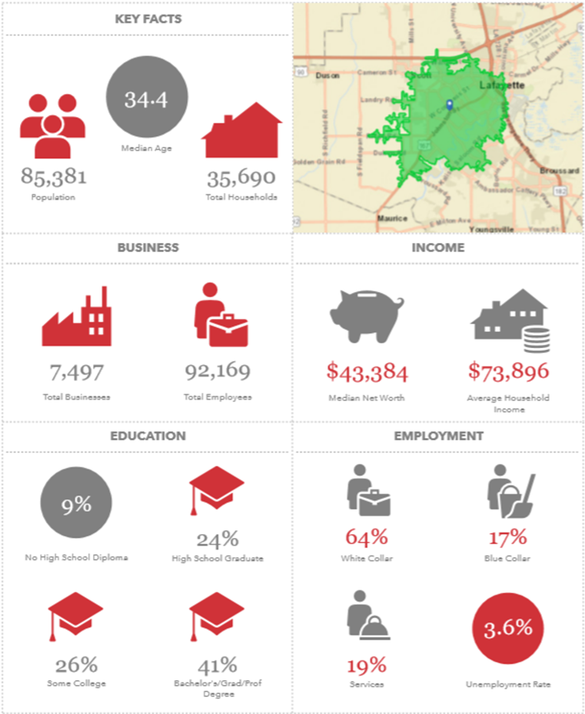

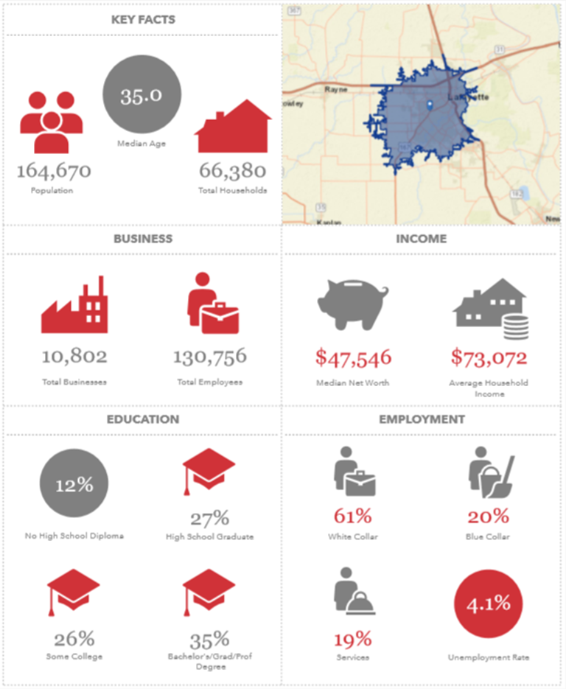

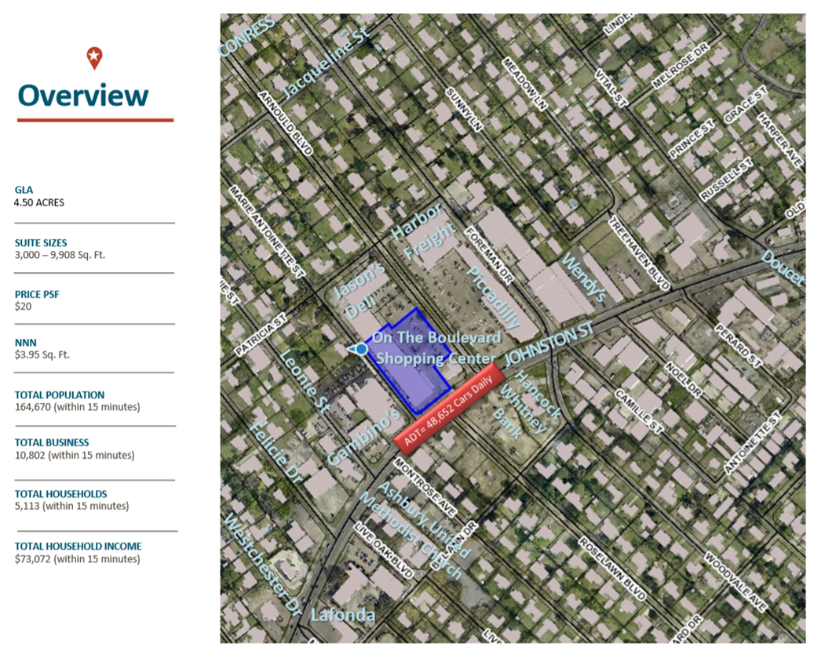



Exhibit E
On The Blvd Shopping Center
February 2020 – Exterior Pictures
Jason’s Deli, 149 Arnould Blvd., Lafayette, Louisiana

